Introduction

These guidelines cover the classification and packaging of dangerous goods for transport by air only and cover the following substances:

- Exempt Biological substances
- Goods sent on dry ice UN1845
- Category B Biological Substances meeting UN3373
- Genetically Modified Microorganisms / Organisms UN3245

Contact your courier for advice regarding cost, commercial invoices and customs documentation

When sending dangerous goods by air you are agreeing to abide by the requirements of the following pieces of legislation:

- The carriage of dry ice (UN1845) as outlined in the latest edition of the IATA Dangerous Goods Regulations by Air.
- The requirements for the Carriage of Biological Substances as outlined in the latest edition of the IATA Dangerous Goods Regulations by Air.

As a shipper it is your responsibility to ensure:
- Your biological substance has been correctly classified and packaged.
- The package is correctly labelled and marked.
- To accurately complete all associated documentation.
Doing so will ensure compliance with legislation and a smooth transit through customs.

Please note IATA guidelines are revised on a bi-annual basis and legislation can be subject to change. In this event you will be advised accordingly.

Any queries please contact the FBMH Compliance and Risk Team: FBMHhealthandsafety@manchester.ac.uk

Contents:

- Classify your biological substance
- General principles of packaging
- Label outer container and complete documentation
- Exempt Biological Substance
- Dry Ice UN1845
- Genetically Modified Microorganisms / Organisms UN3245
- Category B Biological Substances meeting UN3373

Section 1- Classify Your Biological Substance
Is your biological substance one of the following?
- A non-pathogenic micro-organism (human or animal)
- Dried blood spot/faecal occult blood
- An environmental sample (water, soil etc.) or a material (including material derived from human or animal sources) that has been treated to inactivate an infectious substance
- Naked nucleic acid
- Purified protein e.g. antibodies
- Class I GMOs/GMMs in which the foreign DNA has been incorporated into the genome i.e. no vectors are present
- Cell lines that are certified pathogen- free and, if transfected, have the foreign DNA incorporated into the genome i.e. no vectors are present, provided that any serum present is also free from infectious agents. (If not classify as UN3373)
N

NO

Is your biological substance one of the following?
- Bacterial expression vectors in a bacterial host - GM level 2
- Viral vectors in a eukaryotic host i.e. capable of producing virus particles
- HG3, HG4 and the following HG2 pathogens - Clostridium botulinum and poliovirus
- Any other HG2 pathogens used for research

YES
STOP
Consult the FBMH Biological Safety Manager
NO

Is your biological substance one of the following?
- Clinical samples from otherwise healthy individuals being used for research purposes
- Human primary cells from healthy individuals, but not certified pathogen-free
- Transfected human primary cells from healthy individuals, but not certified pathogen-free

NO

Is your biological substance one of the following?
- Cloning vectors in lab strains of E.coli
- Bacterial expression vector in a bacterial host - GM level 1
- Mammalian expression vectors (viral or plasmid) in E.coli
- Mammalian expression vectors in mammalian host, provided any serum present is also free from infectious agents (if not classify as UN3373)

YES

YES

Biological Substance Category B
UN3373
Follow the packaging, labelling & documentation instructions C

logical Substance Category B UN3373
Packaging instructions A
Labelling /

Genetically Modified Microorganisms UN3245
Follow the packaging, labelling & documentation instructions D

Genetically Modified Microorganisms UN3245
Packaging instructions A
Labelling /
Documentation instructions A

logical Substance Category B UN3373
Packaging instructions A
Labelling /

Exempt Biological Substance
Follow the packaging, labelling & documentation instructions A

Is substance being sent on dry ice UN1845

logical Substance Category B UN3373
Packaging instructions A
Labelling /

YES

Include labelling and documentation instructions B

Section 2 - Packaging of all Biological Substances for transport by air – general principles

Regardless of category or temperature all biological material sent by air must be packaged using the following principles

Inner packaging

- Sealed leak-proof primary receptacle(s)
- Leak-proof secondary packaging; other than for solid substances, an absorbent material of sufficient quantity to absorb the entire contents should they leak must be placed between the primary receptacle(s) and the secondary packaging
- If multiple primary receptacles are placed in secondary packaging, they must be either individually wrapped or separated so as to prevent contact between them.
- Whatever the intended temperature of the consignment, the primary receptacle or the secondary packaging shall be capable of withstanding without leakage an internal pressure producing a pressure differential of not less than 95 kPa and temperatures in the minimum range -40°C to +55°C. Those on dry ice must be able to withstand temperatures down to -80°C without becoming permeable or brittle

An itemised list of contents must be enclosed between layer 1 and layer 2. Use a sealed polythene bag and ink that is unlikely to run if exposed to moisture.

Outer packaging

- Samples on dry ice - Stabilisers (e.g. cut cardboard or polystyrene) to hold secondary container in place as dry ice sublimes away.
Strong crush proof outer container capable of venting CO₂ (e.g. a polystyrene box), not less than 100mm x 100mm in dimension
- Samples that are chilled – Cool packs (not wet ice), strong crush proof outer container e.g. a polystyrene box and not less than 100mm x 100mm in dimension.
- Samples that are at an ambient temperature – use a crush proof outer packing e.g. fibreboard and pad the box with enough material to keep the sample upright should be used. Should you wish to use a padded envelope you must use a rigid secondary container or you risk your sample being crushed during transit.

Overpack

If an overpack is used and unless all package markings are clearly visible, the shipper will mark the overpack with the word “Overpack” and will reproduce all markings on the outside of the overpack.

Either the secondary or outer packaging must be rigid. All packaging must be of good quality, strong enough to withstand the shocks and loadings normally encountered during transport and subsequent manual or mechanical handling. It must be constructed and closed to prevent any loss of contents that might be caused under normal conditions of transport, by vibration, by changes in temperature, humidity or pressure.

NOTE: for transport of UN3245 and UN3373 samples, packaging should be purchased from a recognised packaging company such as AirSea Containers or Intelsius.
A range of specialist packaging is also available from Stopford Stores.

Dry ice transport diamonds and dry ice weight labels are available from the Michael Smith and AV Hill building receptions, and can be purchased from Stopford Stores.
Alternatively they can be purchased from AirSea Containers or Intelsius.

Section 3 - Labelling and Documentation

- Exempt Biological Materials

- Outer container: Name and address of Shipper and Consignee
- Air waybill: in description of goods write “Biological material, non-hazardous goods no of items x volume in ml” e.g. Biological material, non-hazardous goods, 100 x 0.5ml

Commercial invoice / toxic substances form: May be required if sending outside of the EU. If you are uncertain contact your courier.
In description of goods write “Biological material, non-hazardous goods. These products have no commercial value. “You will need 4 copies of this to present with your waybill

Import / Export documentation: if required. If you are uncertain contact your courier.

- Dry Ice Parcels

An adhesive waterproof UN1845 transport diamond must be displayed on the external surface of the outer packaging. The mark must be in the form of a square set at an angle of 45° (diamond-shaped) with each side having a length of at least 50 mm (2 in). Also required is an adhesive waterproof Dry Ice UN 1845 label with the net weight of dry ice entered in permanent marker.

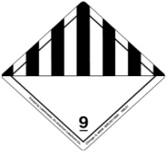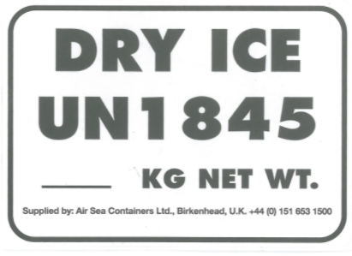

Apply a waterproof label with the name and address of Shipper and Consignee. These labels are available from the Michael Smith and AV Hill receptions.

When the labels are applied, ensure they are waterproof, clearly marked, not obscured in any way and do not turn corners.
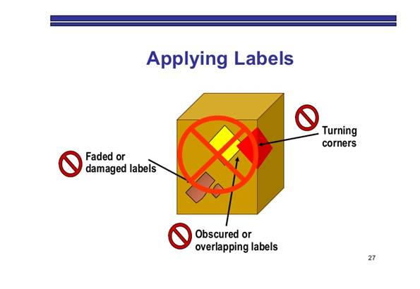

The Air Waybill should contain the following information in the “Nature and Quantity of Goods” box
- The Air waybill: in the description of goods “UN1845, Dry ice, Class 9 x [number of] kg”
- The UN Number UN1845
- The words “Carbon dioxide, solid” or “Dry ice”
- The number of packages of dry ice
- The net quantity of dry ice in kilograms
- The nature and quantity of the biological substance e.g. “Biological material, non-hazardous goods no of items x volume in ml”

Commercial Invoice / toxic substances form: May be required if sending outside of the EU. If you are uncertain contact your courier.
Ensure you insert the safety phrase “On dry ice [number of] kg (compliant with UN1845) these products have no commercial value”
You will need 4 copies of this to present with your waybill
Import / Export documentation if required. If you are uncertain contact your courier.

Once your sample is packaged and labelled ensure you have completed the dry ice acceptance checklist, get it checked by your PI and retain a copy.
The current dry ice acceptance checklist can be downloaded from the FBMH intranet.

- Category B Biological Substances

A waterproof UN3373 transport diamond must be displayed on the external surface of the outer packaging The mark must be in the form of a square set at an angle of 45° (diamond-shaped) with each side having a length of at least 50 mm (2 in), the width of the line must be at least 2 mm and the letters and numbers must be at least 6 mm high.

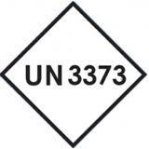Biological Substance, Category B

The proper shipping name “Biological Substance, Category B” in letters at least 6 mm high must be marked in permanent marker on the outer packaging adjacent to the diamond.

Apply a waterproof label with the name and address of Shipper and Consignee
SHIPPER  Dr A Parcel  Faculty of Biology, Medicine and Health  etc. | CONSIGNEE  Dr A Opener  University of Receiver  etc.

You will need a 24 hour emergency contact number on either the label or the airway bill.
Air waybill: must contain the following words in the description of goods “Biological Substance Category B UN3373, no of samples x volume in ml”

Commercial Invoice / toxic substances form: May be required if sending outside of the EU. If you are uncertain contact your courier.
The following safety phrase is required under the “Completed detailed description of goods” section:
Specimens compliant with IATA regulations for Biological Substance Category B - UN3373 no of samples x volume in ml”
Under “Reason for export” state:
“Specimen packed in compliance with PKG INS 650 Shipment and is being transported for research. These products have no commercial value.”
You will need 4 copies of this to present with your waybill

Import / Export documentation if required. If you are uncertain contact your courier.
D: Genetically Modified Microorganisms / Genetically Modified Organisms

A waterproof UN3245 transport diamond must be displayed on the external surface of the outer packaging The mark must be in the form of a square set at an angle of 45° (diamond-shaped) with each side having a length of at least 50 mm (2 in), the width of the line must be at least 2 mm and the letters and numbers must be at least 6 mm high.

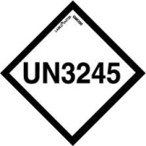Genetically Modified Microorganism / Genetically Modified Organism (select appropriate statement)

The proper shipping name “Genetically Modified Microorganism / Genetically Modified Organism” in letters at least 6 mm high must be marked in permanent marker on the outer packaging adjacent to the diamond.

Also include the name and address of Shipper and Consignee on a waterproof label

SHIPPER  Dr A Parcel  Faculty of Biology, Medicine and Health  etc. | CONSIGNEE  Dr A Opener  University of Receiver  etc.
You will need a 24 hour emergency contact number on either the label or the airway bill.

Air waybill: must contain the following words in the description of goods “Genetically Modified Microorganism / Genetically Modified Organism (select appropriate statement) UN3245, no of samples x volume in ml”

Commercial Invoice / toxic substances form: May be required if sending outside of the EU. If you are uncertain contact your courier.
The following terminology is required under the “Completed detailed description of goods” section:
Specimens compliant with IATA regulations for Genetically Modified Microorganisms / Genetically Modified Organisms (select appropriate statement) UN 3245 no of samples x volume in ml”
Under “Reason for export” state:
“Specimen packed in compliance with PKG INS 954 Shipment is being transported for research. These products have no commercial value” You will need 4 copies of this to present with your waybill

