Safe Storage of Hazardous Substances

Laboratory Health and Safety Inspections have found issues with unsafe storage of hazardous substances and poor chemical hygiene practices. This can have serious consequences for the safety of your staff and students and needs to be managed from the time the substance is ordered right through to its safe disposal.

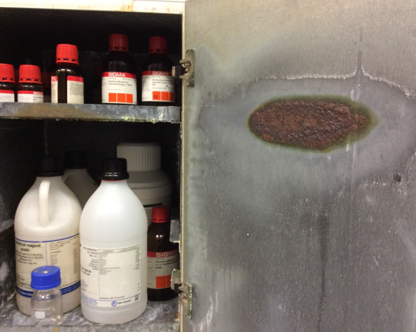
Example of how not to store chemicals

Problems include:

- Cabinet degradation caused by storing corrosives in a flammables cabinet

- White powder formed by storing incompatible corrosives together which have reacted

- Expired substances taking up space and becoming highly unstable during long term storage

What you need to do:

- Check your fridges, freezers, shelves, storage cabinets and fume hoods for hazardous substances.
- Dispose of expired and unwanted stocks via Stopford Stores hazardous waste disposal if you are in the Biomedical Corridor, otherwise refer to your local rules.
- Ensure your remaining substances are clearly labelled i.e. the chemical name, Cas. No and any associated pictograms are clear and also your research group name and expiry date are written on.
- Store them in the appropriate location, at the correct temperature and ensure incompatible materials are not stored next to each other. Remember – the fume hood is not an appropriate storage location.
- You may find this compatibility table for chemical storage a useful reference guide for your lab.
- Following the guidance on the Procurement and Storage of Hazardous Substances intranet page, develop and follow a robust chemical hygiene plan, for procurement and storage of hazardous substance and chemical waste management. Ensure safe storage and disposal considerations are included in your COSHH risk assessments. You will require an additional storage Standard Operating Procedure (SOP) if the substance is can become unstable in storage such as peroxide forming solvents, formation of contact sensitive explosive crystals or any other hazardous by-product.
- Report any damaged storage cabinets to your Technical Operations Manager.
- Ensure your storage cabinets are correctly labelled (labels available from the Compliance and Risk Team).

WARNING – should you identify hazardous substances in damaged containers, with a visible precipitate or signs of crystal formation, identify old peroxide forming solvents or are otherwise concerned do not touch them – contact your nearest Safety Advisor or a member of the Compliance and Risk manager as quickly as possible.

