
Safety Services
The University of Manchester Simon Building,
Brunswick St
Manchester M13 9PL

Safety Circular 2-2019

To | Dame Nancy Rothwell, Mr Patrick Hackett, Profs Keith Brown, Graham Lord,  James Thompson and Martin Schröder
From | Dr Patrick Seechurn, Head of Safety Services
Date | 18 July 2019
cc | Prof N Thakker, Dr S Chiu, HOSs, DOFOs, HOSAs, Directors, School Safety Advisors, Safety Representatives
The safe use of laser pointers

Action required: Senior managers should assure themselves that:

- All laser pointer users are aware that pointers used in University presentations/lectures must be labelled LASER RADIATION DO NOT STARE INTO BEAM CLASS 2 LASER PRODUCT, have a maximum power of <1mW, be CE marked and have been tested to EN 60825-1. This information is required on either the product or the accompanying data sheet.
- Any pointers not stating this, or bearing the label ‘Class II laser product complies with 21 CFR’ must be assessed before further use to confirm the classification according to EN 60825-1.

Background
A recent exercise was carried out whereby seven laser pointers were randomly tested.

Only one of the seven was accurately labelled as a Class 2 laser and safe to use as intended. The others were up to fifty times more powerful and could readily cause injury.

Examples of the incorrectly labelled pointers are shown overleaf. Lasers labelled ‘Class II laser product complies with 21 CFR’, are to an American Standard and may be more powerful than anticipated. Lasers used in the University need to comply with the European Normative standard EN 60825-1, and the British Standard version BS EN 60825-1.

Consequences of using incorrectly labelled lasers
Class 2 lasers are normally safe due to the eye's natural aversion response and suitable for laser pointers used in lectures/presentations; however if pointed directly into the eye they may cause injury. Lasers with a higher classification are not suitable for lectures/presentations.

How to determine if your pointer is safe to use
All laser pointers used in University presentations/lectures must be labelled Class 2 according to EN 60825-1, have a maximum power of <1mW, and carry a CE mark. It is acceptable for this labelling to appear on a datasheet accompanying the laser when the laser is too small for labels.

If the laser pointer does not come with this labelling or on the accompanying datasheet then it must be assessed before use in lectures or presentations. Contact your School Laser Safety Advisor or School Safety Advisor to arrange an assessment.

At the time of writing the Trust Taia Wireless Presenters model 20405 has been identified as a EN60825-1 compliant model and is available on iProc. Please purchase this laser pointer.
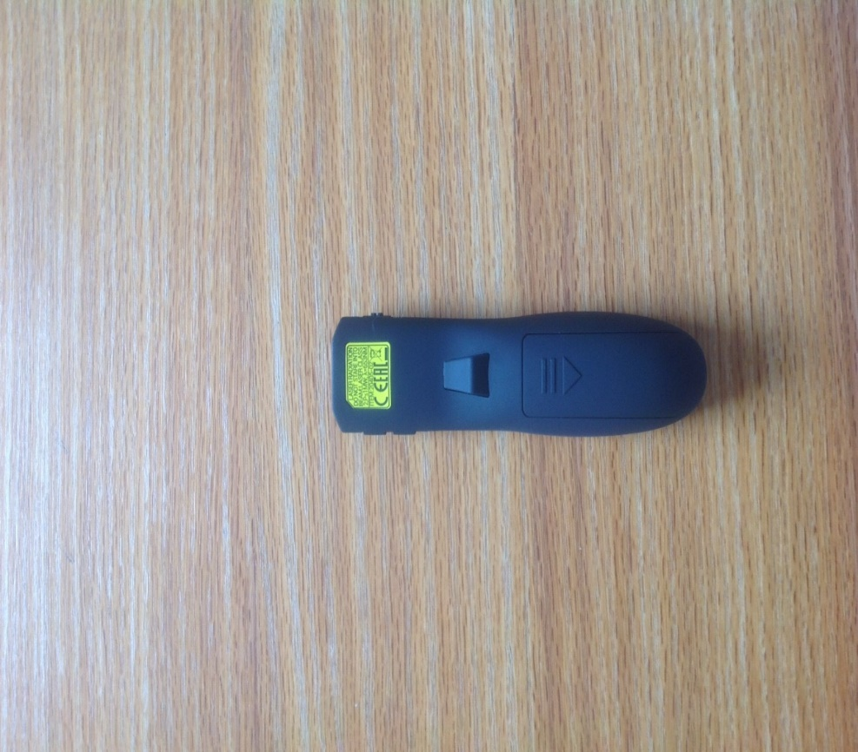
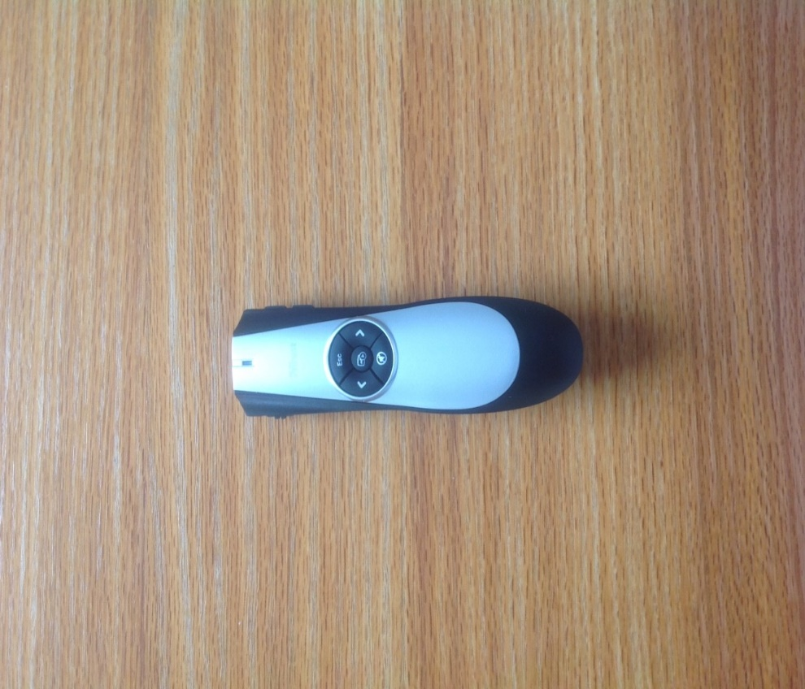
Trust Taia Wireless Laser Presenter
Manufacturer’s part number: 20405-02
Supplier: Insight Direct (UK) Ltd

Examples of Laser Pointers which may cause eye injury
Examples of the incorrectly labelled pointers are shown below. Lasers labelled

- MAX OUTPUT POWER <1mW Wavelength 650nm±10 Class II LASER PRODUCT This product complies with 21 CFR

are made to a US standard and may be more powerful than anticipated.

The lasers below were tested by the School of Physics and Astronomy and all found to be Class 3B and unsuitable for use. One of them has a power output fifty times that of a 1mW Class 2 laser.

Dr Patrick Seechurn
Head of Safety Services

